Coal Mining - The Start in the North-east of England
Learning Objectives.
- How mining started in our area
- The start of mining in Hetton
- To learn about the coal mines in the Hetton area.
There are reasons to believe that the Romans in our area collected coal to burn about 2000 years ago. They often found the coal washed up on the beaches after storms. This coal came from coal seams which came to the surface under the sea. They also dug coals where seams showed themselves on the side of hills.
We know that monks in the Medieval Period (A.D. 600 – A.D. 1500), at least 700 years ago collected coal for burning and keeping warm. Records exist showing the Monks of Finchale Abbey near to Durham City owned land at Rainton and Houghton from which coal was being taken. This showed that there was coal seams near to Hetton.
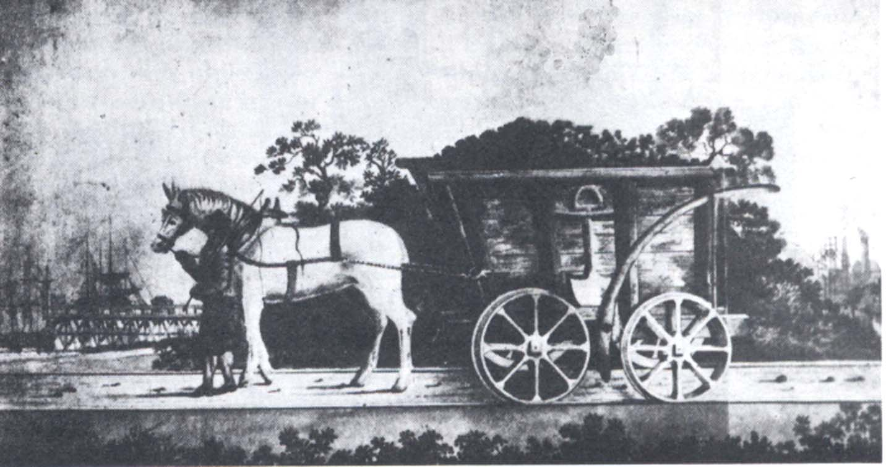
The first coal mines in County Durham were started around the 1600s (15th century). They were found near to the River Wear where the coal could be taken by horse drawn ‘trucks’ called chaldrons from the pits down to the river bank where it was loaded into boats called keels. The keels then took the coal down river to the river mouth at Sunderland where it was loaded into bigger ships called colliers.

A horse pulling a chaldron waggon
Colliery

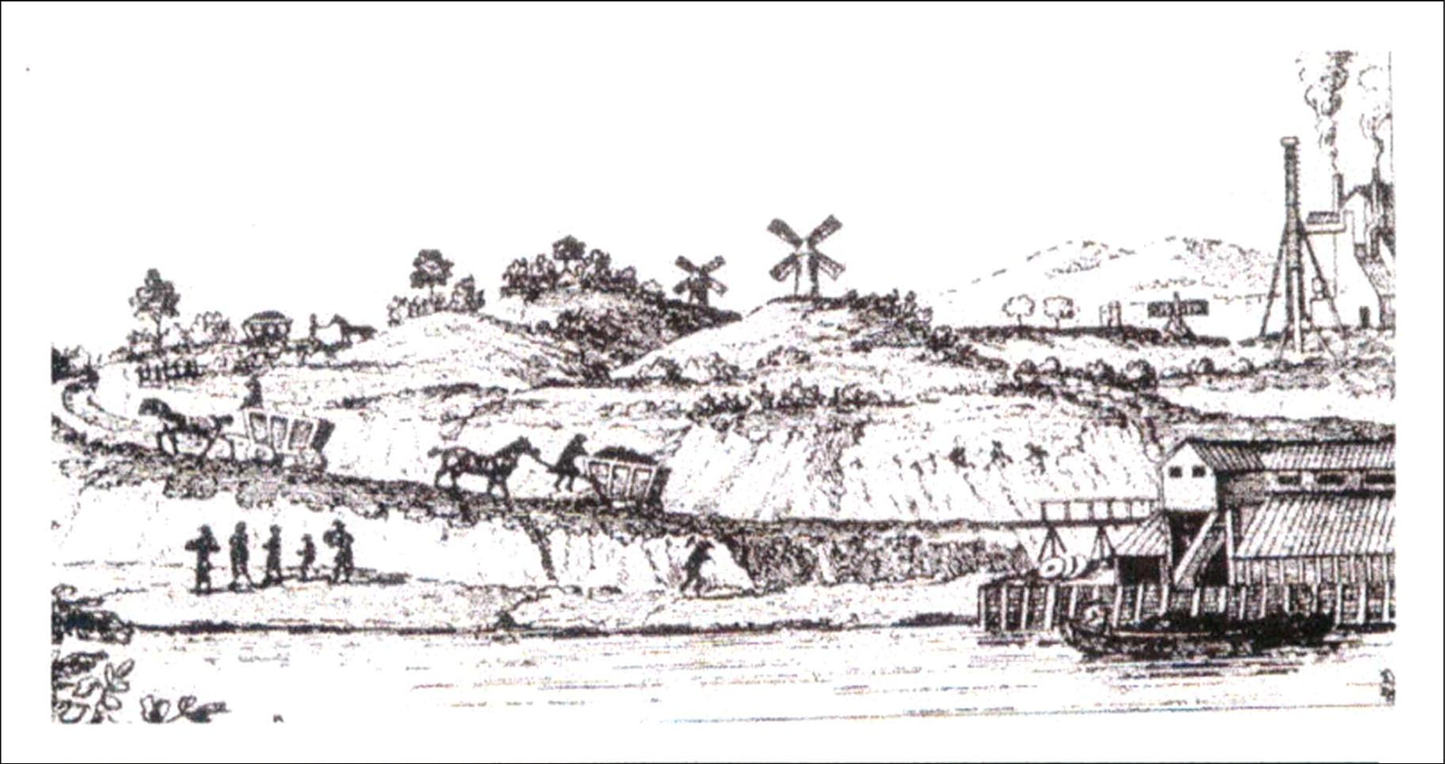
Chaldron waggon
Keel boat
Taking coals from the pit to the river.
Many of the first pits were found near to the town of Washington, 10 kilometres from Hetton. Finally in 1819 a group of men got together in Hetton and formed the Hetton Coal Company. They believed that there was coal underneath the village of Hetton which at that time was only about ten houses. The coal, if it was there, was at a much deeper level than any other coal seams in the area so they started to bore down by drilling into the earth. In 1820 they found coal at a great depth and they then decided to sink a colliery to get it out. This pit was called the Hetton Colliery or the Lyons Colliery because the pit shaft was on land owned by John Lyon who lived at Hetton Hall,(where the swimming baths are today).
By November 1822 the first coals were being brought out of the colliery and taken by a brand new railway called the Hetton Railway directly to the port of Sunderland to be loaded into colliers (ships).

