How Coal came to Hetton Part 5
The start of the Mining Communities.
Learning Objectives
- To show how the early mining communities were established
- Describe the conditions under which the miners and their families lived.
One of the problems faced by the coal owners when they started constructing a colliery, was that more often than not ,they did not own the land on which the colliery was sunk. Thus they had to pay the land owner a fairly large sum of money or invite him or her to become one of the owners of the colliery. The coal owners also had to build houses for the miners and their families and they had to seek permission to build the cottages on someone else’s land. They then had to squeeze as many houses as possible on to the land and because of this, miners’ cottages were small and lacked the basic amenities which we expect today.
The coal owners built the cottages for as little money as possible and they were just slum properties. They had no proper heating other than a single coal fire so in the winter the house was cold. Sometimes the roofs leaked and there were no toilets. If toilets were provided the families from the whole street would use them and they would be found close to houses. There was no tap water; water was collected in a barrel as run-off from rain water coming off the roof. Water from nearby springs, which was not always pure, was sold by a water carrier who carried water in barrels on a horse and cart. There were no proper drains or collection of household rubbish such as uneaten food, this was dumped at the end of a street on what was called a midden. Toilet waste was often dumped here too.
Due to the poor state of the houses it was difficult to keep houses clean and it was easy for certain diseases to break out in the community. Diseases such as smallpox, typhoid and dysentery were very common due to the bacteria which people came into contact with in everyday life. Many children died before they reached the age of five and it was usual for people to die before the age of 40.
In Hetton the early houses were built with a yellow limestone from the local quarry at Eppleton or Moorsley. Bricks were not used until after the 1850s when brickworks were built close to pits, using the clay which came out of the pits to make the bricks. Both the Lyons Colliery and Moorsley pit had brickworks. The stone was cheap and was called rubble stone since most of the stones did not have a good shape but were held together with cement.
Many of the houses were built close to the pit and this was a dangerous place for children to play and there were a number of deaths and accidents because of it.
Year Number of Households Population number
1801 53 253
1811 56 322
1821 109 994
1831 1062 5951
1841 936 4260
1851 1144 5751

The figures above show how the population of Hetton grew very quickly. Even though the houses were small family size was often large. It was not uncommon for families size to be, ten, eleven , twelve or even more. Many cottages were overcrowded particularly during the 1820s and 1830s. Below is an statement made by a miner who lived in the Brickgarth after 1830 :-

“There were six brothers besides myself and six sisters. Now then, you had to divide the rooms into two, particularly the loft where we all slept. This meant three or four sleeping in a bed. It was very cold in the winter and we often slept with our clothes on while in the summer it was red hot and it was impossible to sleep more than a few hours. I was born in the middle of the family and it was my job to look after the young ones and run messages for the older ones. I never got a minute to myself. On Mondays, wash day, I often looked after the younger children while my mother did the washing which took all day. She never got a minute, always cooking, cleaning, polishing, washing and mending. When my older brothers started work it was worse because they worked different shifts at the pit and they kept coming and going night and day and had to be bathed and fed.”

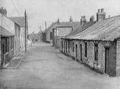
A very old photo shows miners’ cottages in the Brickgarth Easington Lane

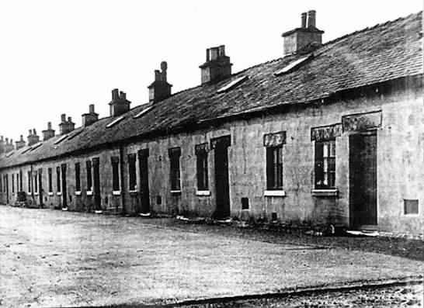
These miners’ cottages were in a County Durham mining village. The cottages were built in the 1890s and are similar to those built in Hetton around the same time.

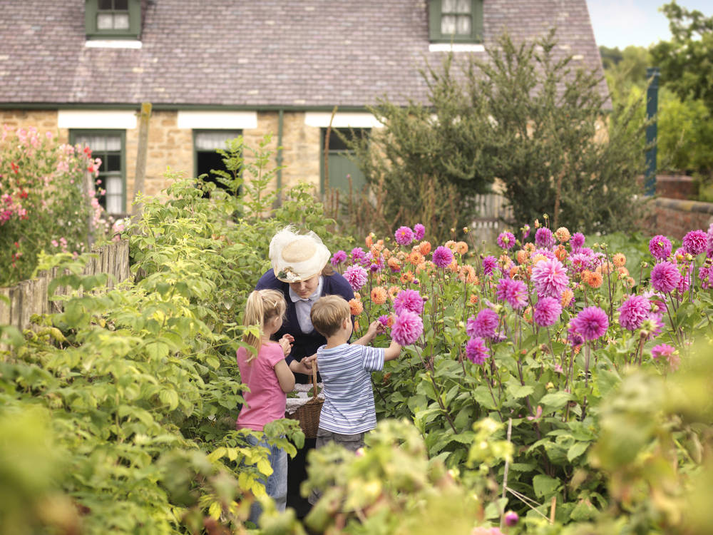
This photo taken at Beamish Museum shows some miners’cottages which came from Francis Street in Hetton and rebuilt at the museum. They were built around 1900 and were a big improvement on the early cottages in Hetton. Notice that there is a window in the roof for the loft space, these were added in the 1930s to improve the houses. Each house also had a garden or allotment where vegetables could be grown.
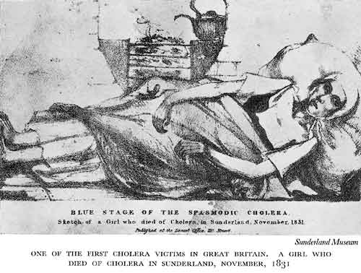
Diseases such as Typhus, Dysentery, Cholera and Smallpox were common in communities where living conditions were very poor

